EKISC General Contractor Expression of Interest (EOI)

&

Grassland Rangeland Enhancement Program (GREP) (“Rancher-Sprayer”) EOI Info-sheet

If you would like to apply (due date for 2022: April 6th, 11:59 PM) please contact:
Katie Reid, Program Director
katie@ekisc.com, 250-423-0198

A full application will be emailed to you.

General Contractors: The East Kootenay Invasive Species Council (EKISC) hires several contractors annually for Invasive Plant (IP) Management work. An Expression of Interest (EOI) is typically circulated late winter/early spring and evaluated using a scoring system. There are several requirements that a contactor needs to qualify, including up-to-date Pesticide Applicator Certification, a Pesticide Service License, WorkSafe BC coverage, a variety of insurance documentation, among other criteria.
General Contractors work description: IP management work consists of Invasive Plant Inventory and Treatment in the Regional District of East Kootenay within British Columbia. The general nature of IP work consists of operational services related to the survey, treatment, and monitoring of designated invasive plant species that are found on a variety of jurisdictions, including but not limited to: Ministry of Transportation and Infrastructure (MOTI), Ministry of Forests, Lands, Natural Resource Operations and Rural Development (FLNRORD), Ministry of Environment (MOE), Conservations Lands, Private and Industrial Properties, and may include road rights-of-way, community pastures, forest openings, gravel pits, and quarries. The goal of this work is to prevent new introductions, and reduce existing, invasive plant species spread.
GREP Rancher- Sprayers: The East Kootenay Invasive Species Council (EKISC) administers the GREP for contracted “rancher-sprayers” who annually conduct Invasive Plant (IP) Management work. An Expression of Interest (EOI) is typically circulated late winter/early and there are several requirements that a contactor needs to qualify, including up-to-date Pesticide Applicator Certification, and a Pesticide Service License.
GREP Rancher-Sprayer work description: Rancher-sprayer work consists of Invasive Plant Inventory and Treatment in the Regional District of East Kootenay within British Columbia. The general nature of the Work to be carried out consists of operational services related to the survey and treatment of designated invasive plant species that are found on Ministry of Forests, Lands, Natural Resource Operations and Rural Development (FLNRORD) Crown land range tenures. The goal of this work is to prevent new introductions, reduce existing infestations, and improve forage availability on Crown land range tenures. The work may be performed by the Crown land range tenure holder, or individuals employed or engaged in the performance of work on the Rancher-sprayer’s range unit
General Information:
EKISC also evaluates whether a contractor has a proven record of compliance with the Integrated Pest Management Act and Integrated Pest Management Regulation and full knowledge of the Invasive Plant Pest Management Plan for Provincial Crown Lands in the Southern Interior Region of British Columbia (PMP CONFIRMATION # 402-0678-19/24). Professional references in the IP management field are also required.
IP management in the East Kootenay’s is organized within Invasive Plant Management Area (IPMAs). The map below illustrates the IPMAs.
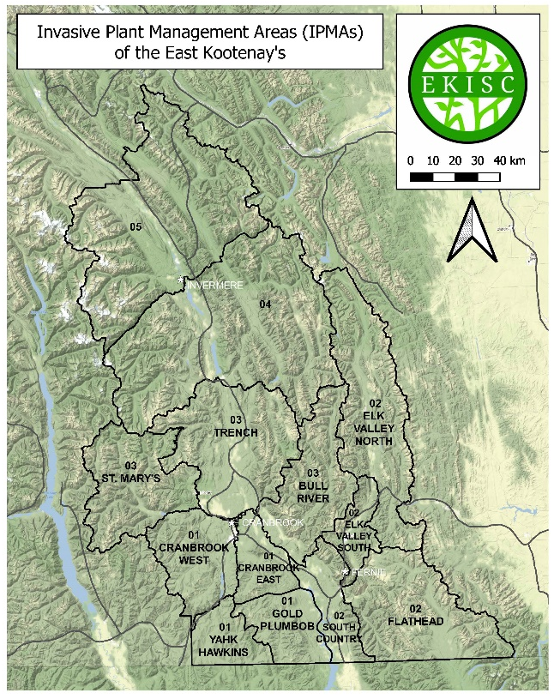
When indicating which IPMA(s) you seek in the Expression of Interest, it will be assumed that you are expressing interest in the four main funders within that IPMA – MFLNRORD, MOTI, FortisBC, and BC Hydro unless otherwise indicated; or a range tenure (GREP). In most IPMA’s, there are additional contributing funding sources (i.e. Conservation Properties), other than the four main funders. When expressing an interest for an IPMA, please indicate your capacity for each IPMA of interest on the Expression of Interest Submission Form. Capacity is expressed as total amount of workdays.
Major Contracts by IPMA ($)
 |  | 2020 |  |  |  | 2021
IPMA |  | MFLNRO | MOTI | BC Hydro | Fortis | MFLNRO | MOTI | BC Hydro | Fortis
1 | Cranbrook East | 7,875 | 7,537 | 2,000 | 2,590 | 9,656 | 8,550 | 4,000 | 2,590
 | Cranbrook West | 10,489 | 9,988 | 1,900 | 700 | 6,613 | 9,900 | 900 | 700
 | Gold Plumbob | 13,875 | 3,268 | 0 | 0 | 15,085 | 3,300 | 0 | 0
 | Yahk Hawkins | 3,750 | 245 | 0 | 0 | 4,648 | 255 | 0 | 0
2 | Elk Valley North | 22,110 | 4,835 | 1,580 | 1,500 | 8,725 | 4,850 | 323 | 1,500
 | Elk Valley South | 3,000 | 6,470 | 300 | 0 | 3,575 | 7,000 | 300 | 0
 | Flathead | 12,188 | 245 | 0 | 0 | 8,616 | 245 | 0 | 0
 | South Country | 24,250 | 12,386 | 1,000 | 1,300 | 15,527 | 12,750 | 1,176 | 1,300
3 | Bull River | 11,265 | 6,220 | 1,500 | 0 | 44,118 | 6,250 | 1,500 | 0
 | St. Mary's | 6,750 | 1,725 | 400 | 0 | 10,725 | 1,750 | 400 | 0
 | Trench | 16,875 | 17,030 | 3,100 | 2,100 | 23,943 | 16,750 | 3,312 | 2,100
4 | 4 | 20,573 | 9,171 | 1,400 | 0 | 20,234 | 9,000 | 1,400 | 0
5 | 5 | 8,250 | 13,190 | 2,400 | 0 | 12,165 | 13,250 | 2,030 | 0

The below table summarizes the total number of invasive plant treatment sites and hectares treated per IPMA for the years 2019 through 2021. This is included to illustrate the large capacity requirement for treating each individual IPMA, and the variable nature of funding (e.g., number of treatment sites and hectares treated vary within each IPMA between years).
Chemical Treatments Per IPMA
Year | 2019 |  | 2020 |  | 2021
IPMA | # of Treatment Sites | Hectares Treated | # of Treatment Sites | Hectares Treated | # of Treatment Sites | Hectares Treated
01 Cranbrook East | 112 | 79 | 80 | 48.6 | 207 | 61
01 Cranbrook West | 94 | 79 | 44 | 58 | 86 | 40
01 Gold Plumbob | 98 | 78 | 148 | 59 | 198 | 42
01 Yahk Hawkins | 33 | 11 | 1 | 0.5 | 32 | 7
02 Flathead | 82 | 50 | 82 | 123 | 66 | 31
02 South Country | 377 | 309 | 513 | 283 | 351 | 209
02 Elk Valley North | 111 | 7 | 144 | 16 | 420 | 132
02 Elk Valley South | 82 | 9 | 47 | 10 | 70 | 31
03 Bull River | 73 | 41 | 94 | 108 | 88 | 122
03 St. Mary's | 39 | 8 | 28 | 9 | 32 | 9
03 Trench | 168 | 38 | 276 | 100 | 230 | 133
4 | 262 | 46 | 190 | 25 | 161 | 11
5 | 295 | 22 | 169 | 8 | 217 | 15

